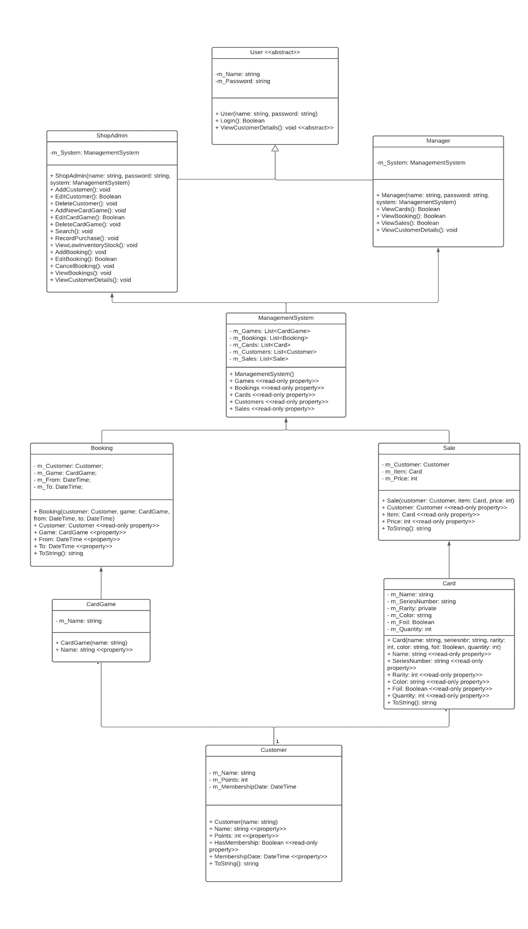

Figure : UML Diagram CardGamesShop.